PIZZA SALES ANALYSIS QUERIES

A.KPIs:-

**1. Total Revenue:**

SELECT SUM(total_price) AS Total_Revenue FROM pizza_sales;

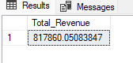

**2.Average order value:**

SELECT (SUM(total_price) / COUNT(DISTINCT order_id)) AS Avg_order_Value FROM pizza_sales;

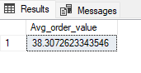

**3.Total pizza sold:**

SELECT SUM(quantity) AS Total_pizza_sold FROM pizza_sales;

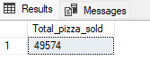

**4.Total orders:**

SELECT COUNT(DISTINCT order_id) AS Total_Orders FROM pizza_sales;

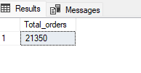

**5.Average pizzas per order:**

SELECT CAST(CAST(SUM(quantity) AS DECIMAL(10,2)) /

CAST(COUNT(DISTINCT order_id) AS DECIMAL(10,2)) AS DECIMAL(10,2))

AS Avg_Pizzas_per_order

FROM pizza_sales;

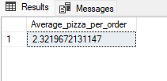

**B. Daily trend for total orders**

SELECT DATENAME (DW, order_date) AS order_day, COUNT (DISTINCT order_id) AS total_orders

FROM pizza_sales

GROUP BY DATENAME (DW, order_date);

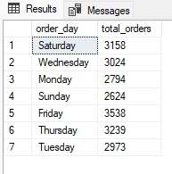

**C. Hourly Trend for Orders**

SELECT DATEPART (HOUR, order_time) as order_hours, COUNT (DISTINCT order_id) as total_orders

from pizza_sales

group by DATEPAR (HOUR, order_time)

order by DATEPART (HOUR, order_time);

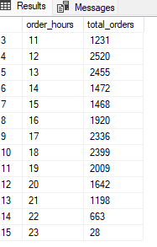

**D. % of Sales by Pizza Category**

SELECT pizza_category, CAST (SUM (total_price) AS DECIMAL(10,2)) as total_revenue,

CAST (SUM (total_price) * 100 / (SELECT SUM (total_price) from pizza_sales) AS DECIMAL (10,2)) AS Percentage_of_total_sales

FROM pizza_sales

GROUP BY pizza_category;

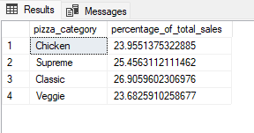

**E. % of Sales by Pizza Size**

SELECT pizza_size, CAST (SUM (total_price) AS DECIMAL (10,2)) as total_revenue,

CAST (SUM (total_price) * 100 / (SELECT SUM (total_price) from pizza_sales) AS DECIMAL (10,2)) AS Percentage_of_total_sales

FROM pizza_sales

GROUP BY pizza_size

ORDER BY pizza_size;

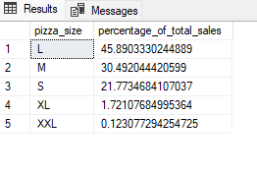

**F. Total Pizzas Sold by Pizza Category**

SELECT pizza_category, SUM (quantity) as Total_pizza_Sold

FROM pizza_sales

GROUP BY pizza_category

ORDER BY Total_pizza_Sold DESC;

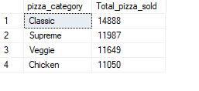

**G. Top 5 Best Sellers by Total Pizzas Sold**

SELECT Top 5 pizza_name, SUM (quantity) AS Total_Pizza_Sold

FROM pizza_sales

GROUP BY pizza_name

ORDER BY Total_Pizza_Sold DESC;

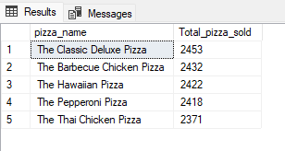

**H. Bottom 5 Best Sellers by Total Pizzas Sold**

SELECT TOP 5 pizza_name, SUM (quantity) AS Total_Pizza_Sold

FROM pizza_sales

GROUP BY pizza_name

ORDER BY Total_Pizza_Sold ASC;

